Game tutorial research

Usually left until late in the product, even in the industry. They’re hard for the team to do, as they have been constantly playing/testing the game so know everything about it. However, they’re the first impression of the game and the first impression can only be achieved once.

Need to take learning styles into account:

* Visual: learn by seeing information, like information in text boxes
* Aural: learn by hearing, like informative dialogue
* Kinetic: learn by/while in motion, like keeping active (busy hands, etc.)

Also, need to be aware of knowledge acquisition, of which there are two styles:

* Explorative – learning by taking risks. This is done by pressing every button or pulling every lever to see what it does
* Modelling: learn the controls and how to play before attempting to play. Typically like to watch others play first, and learn by seeing what does and doesn’t work.

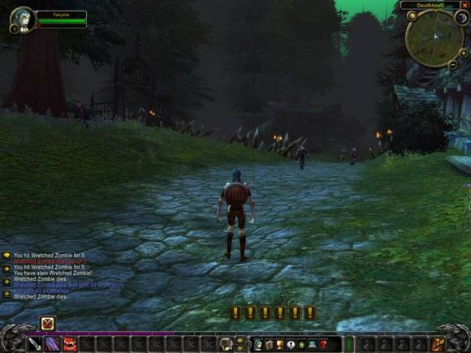

Example of explorative acquisition from World of Warcraft. Players must click on the “!” symbols to learn a new mechanic/activity. Players will click on them as they see them, based on if they use explorative acquisition, but won’t click them at all if the use modelling acquisition as they don’t know what will happen.

Ideally, a tutorial for a modelling learner should only end when the player is comfortable, as they like to repeat actions.

A simple way to make a tutorial for both types of acquisition is to include a “next” button, which allows explorative learners to move freely through anything they find tedious and allows modelling learners to stay and repeat an action as many times as they want.

Tutorial types:

Exposition: showing the player a screen that just lists the control scheme or showing a wall of text that players read to gain information on how to play. Not very effective as most players forget this screen, at least partially, when actual gameplay starts.

example of exposition

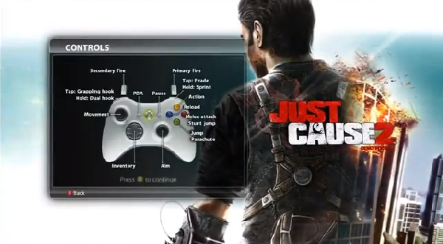

Context: information can be given to the player when it’s relevant, or by pausing the game to revisit the tutorial section, as the player is given all information at once. Can affect the pacing of the game, as players need to regularly pause to get the information.

Pick up and play: games with simple controls that require a player to know the basic controls, but then forces them to experiment. Can be effective with certain learner types, but can force some players to quit the game.

Tutorial room: a sectioned off area that walks the player through the controls and mechanics. Can be effective is used in games with simple control schemes, a limited amount of mechanics and is short, time wise. Too long and players will get bored. Too many mechanics/controls and a player won’t be able to remember the information.

Potential way of telling player controls when the game starts.

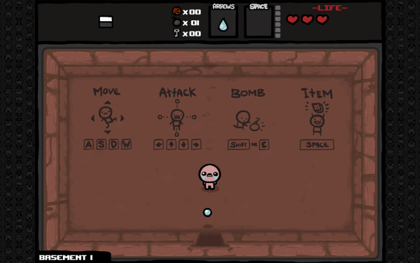

No tutorial can be used, but only if the game and UI have been designed to near perfection.

Use as little text as possible, players want to play, not read.

Buttons with icons can work well, and be used instead of text.

The emotional tone of the tutorial should be positive and encouraging without being patronising.

Most tutorials offer a skip button, so that experienced players can get straight to the game.

Design can be used to tech a player, e.g. if the edge of the map looks like a steep drop, players will know this will hurt/kill them. This is the use of affordances.

Tutorial text should be non-invasive and easily ignored.

**References**

<http://www.gamasutra.com/view/feature/134531/tutorials_learning_to_play.php?page=3>

<https://gamedevelopment.tutsplus.com/tutorials/the-many-ways-to-show-the-player-how-its-done-with-in-game-tutorials--gamedev-400>

<http://www.gamasutra.com/view/feature/134774/the_designers_notebook_eight_.php?print=1>

<https://gamerant.com/video-game-tutorials-good-bad-331/>

<http://www.gamasutra.com/view/news/253028/How_to_train_players_right_so_they_dont_hate_learning_to_play.php>

<http://www.gamasutra.com/view/news/287878/7_introductory_levels_that_all_game_developers_should_study.php>